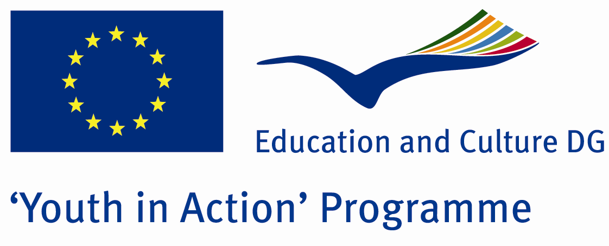

Beginning of the end


ACTION 4.3 – Training And Networking

19-24th september, 2011

Aydin , TURKEY
ACTION 4.3 – Training And Networking

Aydin, TURKEY

Please contact directly to;
adventurerpeacepigeons@gmail.com

Project Summary;

Our Project consists of some workshops and seminars about Global Warming… You know anymore The World is not like our known world… Our animals die, trees are absent, an done day our grandsons can’t see somethings which i see now… So, we must say ‘stop’’ this problem… Because this problem doesn’t belong to just only cuntry… This is our common problem we must solve together... From Africa to Europe… Everybody must be responsible for this problem… With this aim, we start to first step of solution. We hope we go on the steps with you in future… In this Project, some specialist about global warming, will give some seminars and after that we will make some workshops… If you want to join us, please contact with us…

Project Title; Beginning of the end
Date and Venue ; 19-24th september, 2011
Place: Aydin, Turkey.

Target Group ; Municipalities, City Councils and Non-Governmental organizations,
youth groups,culture and art groups,e.t.c

Participants ; 5 people from each country (over 18 -25 ). Totally 8 countries.

Conditions ; Accommodation, board and programme costs will be financed through European Commission Youth in Action Programme . Travel costs will be reimbursed in 70% (APEX Tarrifs). Organizations from all 27 EU member countries plus Liechtenstein , Norway and Iceland are eligible to take part.

Working language: English

Organizer; Adventurer Peace Pigeons

How to apply: If you are interested, please send your Part III forms to
by e-mail please (in word file). Scan Part3 format is enough for application.(Fulfilled Part III which you can find in the attachment, of course signed and stamped) ..

Next step 2;
Original send via regular post to this address please:

Ertan DERİN
Fevzi Çakmak Mahallesi Tuncer Sokak No:6 PENDİK/İSTANBUL/TÜRKİYE
e-mail : adventurerpeacepigeons@gmail.com
Mobile : 0090 542 393 93 90

If you have any questions you may contact with: adventurerpeacepigeons@gmail.com
Deadline: 15th May 2011
For Further information:
Contact Person
Ertan DERİN
Fevzi Çakmak Mahallesi Tuncer Sokak No:6 PENDİK/İSTANBUL/TÜRKİYE
e-mail : adventurerpeacepigeons@gmail.com
Mobile : 0090 542 393 93 90

